**Analysing Sentiments**

**in**

**Earnings Call Transcripts**

**Group 12**

Mritunjay Kumar (A0198457J)

Sum Kwok Hoong (A0198480R)

Tan Dehong (A0198547J)

Tan Wee Han Colin (A0198498Y)

Low Jia Sheng Nelson (A0055398R)

1. **Overview of Business Problem/Value generation**

* Companies hold earnings call with analysts/media every quarter/half yearly and record these proceedings in earnings transcripts.
* Traditionally analysts work with numerical data in company financial statements for their share price projections. However, these are usually laggard data.
* Valuable information and clues on company's prospects could also be extracted from management's speech and opinions in these transcripts. Clues on these prospects could be more important in influencing share prices.
* We seek to extract sentiments from these transcripts via feature engineering of financial/emotional aspects. Machine learning techniques are deployed to predict sentiments for unlabelled transcripts.
* These sentiment scores can then be used to predict future price movements.

1. **Our Business Case**

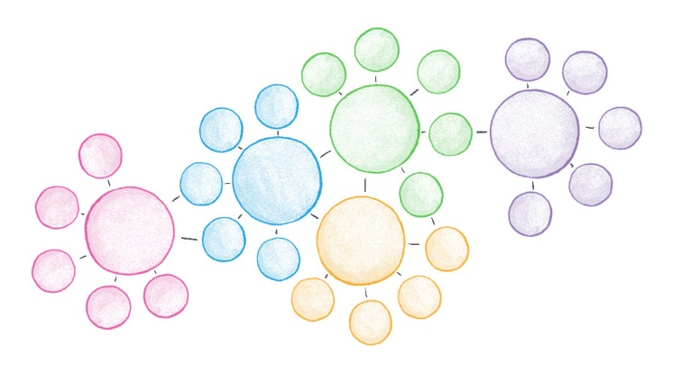

**Topic modelling**

Predict stock price performance for 1/3mths

*Machine Learning*

Train/Predict implicit aspects

Explicit aspects

S&P 500 coys’ text or audio earnings transcript

Explicit aspects

Text Corpus

(tokenized words, sentences)

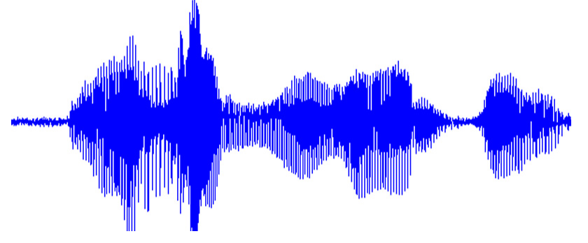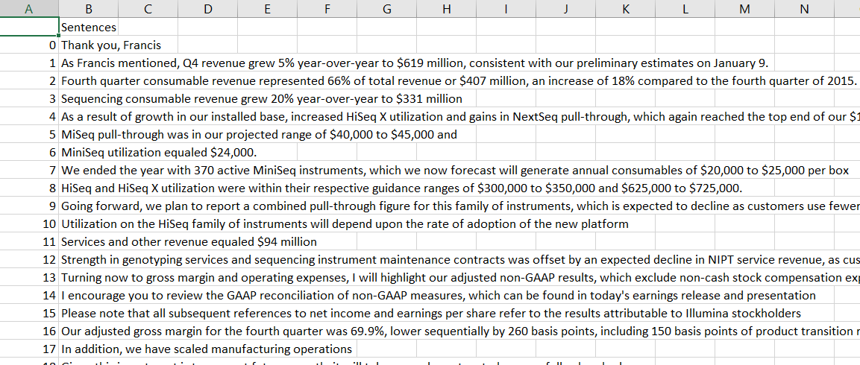

**Aspect Mining**

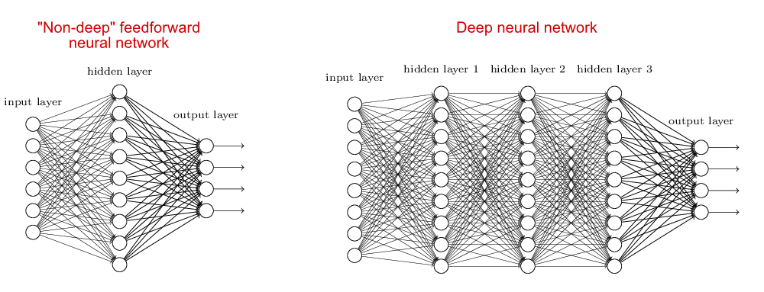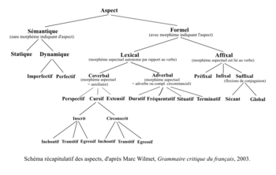



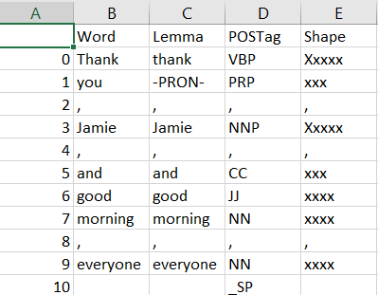

* > 500 transcripts
* >75,000 sentences



*Machine Learning*

[Source: https://github.com/GeminiLn/EarningsCall_Dataset](https://github.com/GeminiLn/EarningsCall_Dataset)

Train/Predict implicit aspects

*Key aspects*

Predict stock price performance for 1/3mths

**Sentiment Mining**



Model

1. **Key NLP Tasks**

* **Topic Modelling**
* Discover key topics (growth-performance, industry-specific) discussed in earnings call to help extract key features
* **Aspect mining**
* Extract key aspects (e.g. “earnings”, “share buyback”) that are deemed to influence future stock performance
* Predict implicit aspects, e.g. “growth” refers to revenue/earnings/margin in any given sentence (via Collocation Detection?)
* **Sentiment Mining**
* Mine sentiments (positive: +1; negative: -1) for each key aspect

1. **Sample Data**

S&P 500 Companies transcripts for FY2017 (Semi-annual/Quarterly)

<https://github.com/GeminiLn/EarningsCall_Dataset>

A screenshot of a social media post

Description generated with very high confidence**PepsiCo Feb 2017**

A screenshot of a social media post

Description generated with very high confidence

**SalesForce Feb 2017**

1. **Possible Conversational UI**

** **

Confidence rating on likelihood

Conversational UI

Query

Will dividends likely to be raised?

**Previous NLP tasks**

Sentiment scores

S&P 500 coys’ text or audio earnings transcript